Link to other group’s doc: <https://docs.google.com/document/d/1rtplLy4rdFxHJhJjVmDBVQYeTaaUEmFjC0WGKjttsDw/edit?ts=5ac68434>

For 𝓐 to be suitable, the *I*𝓐of a structure 𝓐 does not need to define a mapping for BOUND variables. However, it needs to for FREE variables.

When doing substitutions, be aware of the scope of the variables.

**Terms**

A term can be either:

1. A variable
2. A function

This means that a term will always output an element in the universe.

**Predicates**

A predicate will be inputted k number of terms, and output either True or False.

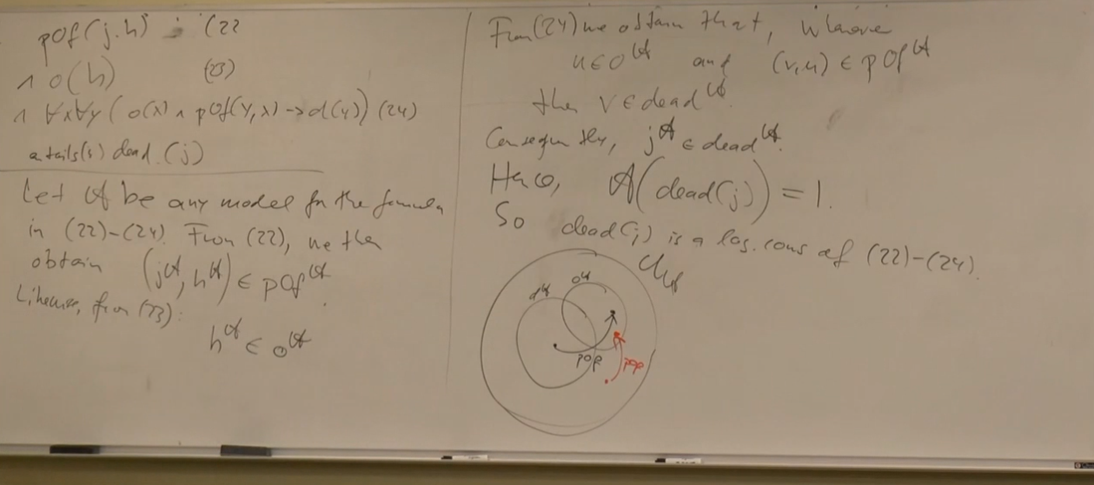

“The orphans are identical to the dead people and everybody who is there which is only one thing is a parent of itself” - Dr. Pascal Hitzler